# Design Patterns and Principles

## Exercise 1: Implementing the Singleton Pattern

public class Logger { private Logger() {

System.out.println("Logger instance created.");

}

initialization)

public static Logger getInstance() { if (instance == null) {

instance = new Logger();

}

return instance;

}

public void log(String message) { System.out.println("[LOG] " + message);

}

}

public class LoggerTest {

public static void main(String[] args) { Logger logger1 = Logger.getInstance(); logger1.log("First log message.");

Logger logger2 = Logger.getInstance(); logger2.log("Second log message.");

// Verify that both logger instances are the same System.out.println("Both logger instances are the same? " +

(logger1 == logger2));

}

}

* **OUTPUT:**

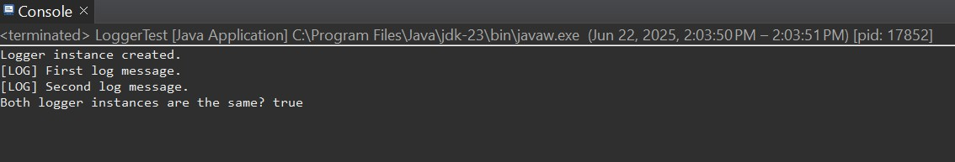

## Exercise 2: Implementing the Factory Method Pattern

public interface Document { void open();

}

public class WordDocument implements Document { public void open() {

System.out.println("Opening Word Document...");

}

}

public class PdfDocument implements Document { public void open() {

System.out.println("Opening PDF Document...");

}

}

public class ExcelDocument implements Document { public void open() {

System.out.println("Opening Excel Document...");

}

}

public abstract class DocumentFactory {

public abstract Document createDocument();

}

public class WordDocumentFactory extends DocumentFactory { public Document createDocument() {

return new WordDocument();

}

}

public class PdfDocumentFactory extends DocumentFactory { public Document createDocument() {

return new PdfDocument();

}

}

public class ExcelDocumentFactory extends DocumentFactory { public Document createDocument() {

return new ExcelDocument();

}

}

public class FactoryPatternDemo { public static void main(String[] args) {

DocumentFactory wordFactory = new WordDocumentFactory();

Document wordDoc = wordFactory.createDocument(); wordDoc.open();

DocumentFactory pdfFactory = new PdfDocumentFactory();

Document pdfDoc = pdfFactory.createDocument(); pdfDoc.open();

DocumentFactory excelFactory = new ExcelDocumentFactory();

Document excelDoc = excelFactory.createDocument(); excelDoc.open();

}

}

* **OUTPUT:**

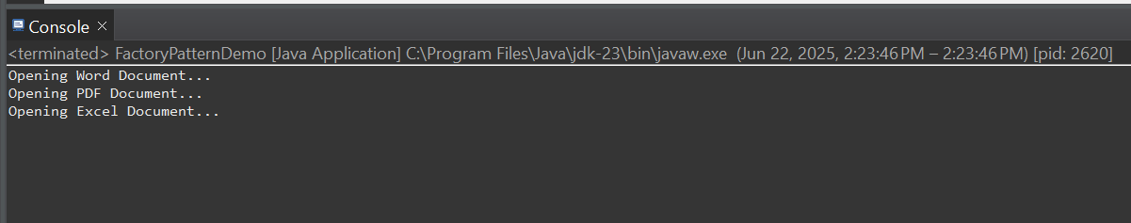

# Algorithms Data Structures

## Exercise 2: E-commerce Platform Search Function

public class Product { private String productId;

private String productName; private String category;

public Product(String productId, String productName, String category) {

this.productId = productId; this.productName = productName; this.category = category;

}

public String getProductName() { return productName;

}

public String getProductId() { return productId;

}

public String getCategory() { return category;

}

@Override

public String toString() {

return productId + " - " + productName + " [" + category + "]";

}

}

public class SearchService {

public static Product linearSearch(Product[] products, String targetName) {

for (Product product : products) {

if(product.getProductName().equalsIgnoreCase(targetName))

{

return product;

}

}

return null;

}

public static Product binarySearch(Product[] products, String targetName) {

int left = 0;

int right = products.length - 1;

while (left <= right) {

int mid = left + (right - left) / 2; int cmp =

products[mid].getProductName().compareToIgnoreCase(targetName);

if (cmp == 0) return products[mid]; if (cmp < 0) left = mid + 1;

else right = mid - 1;

}

return null;

}

}

public class SearchTest {

public static void main(String[] args) { Product[] products = {

new Product("P001", "iPhone", "Electronics"), new Product("P002", "MacBook", "Electronics"), new Product("P003", "T-shirt", "Clothing"),

new Product("P004", "Shoes", "Footwear"),

new Product("P005", "Headphones", "Electronics")

};

Product result1 = SearchService.linearSearch(products, "T- shirt");

System.out.println("Linear Search Result: " + result1);

Arrays.sort(products, (a, b) -> a.getProductName().compareToIgnoreCase(b.getProductName()));

Product result2 = SearchService.binarySearch(products, "T- shirt");

System.out.println("Binary Search Result: " + result2);

}

}

* **OUTPUT:**

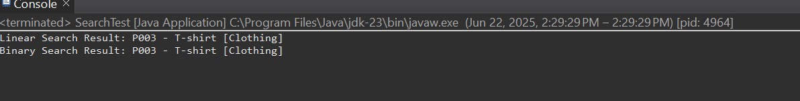

## Exercise 7: Financial Forecasting

public class FinancialForecast {

public static double forecastValue(double currentValue, double growthRate, int months) {

if (months == 0) { return currentValue;

}

return *forecastValue*(currentValue, growthRate, months - 1)

* (1 + growthRate);

}

}

public class ForecastTest {

public static void main(String[] args) { double initialValue = 10000.0; double monthlyGrowthRate = 0.05; int forecastMonths = 6;

double futureValue = FinancialForecast.*forecastValue*(initialValue, monthlyGrowthRate, forecastMonths);

System.***out***.printf("Forecasted Value after %d months:

₹%.2f%n", forecastMonths, futureValue);

}

}

* **OUTPUT:**

